Appendix:

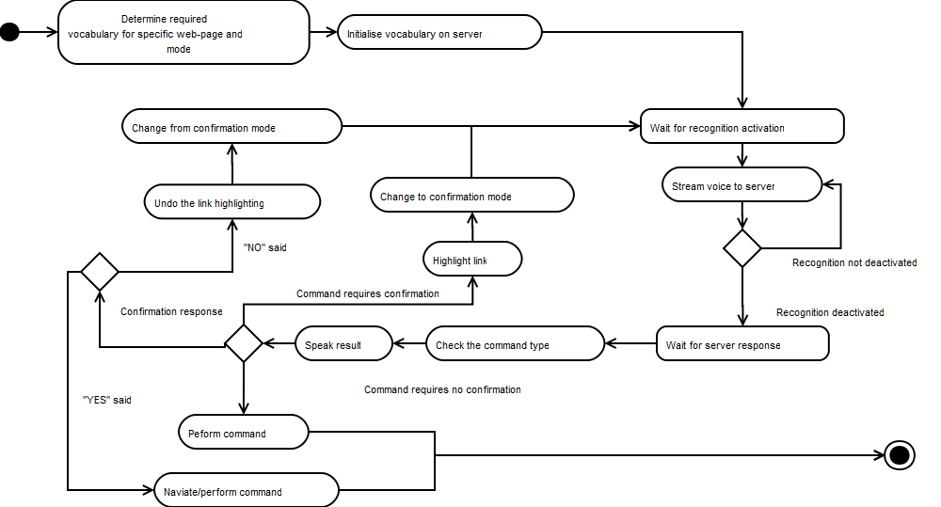

Figure A: Total overview of voice navigation

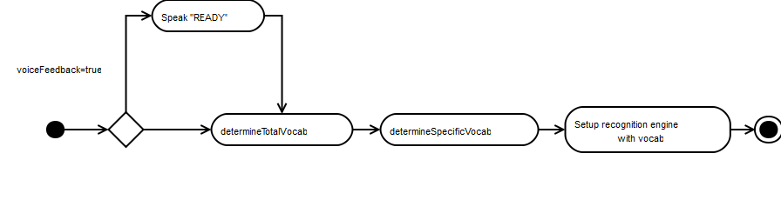

Figure : OnLoaded Overview

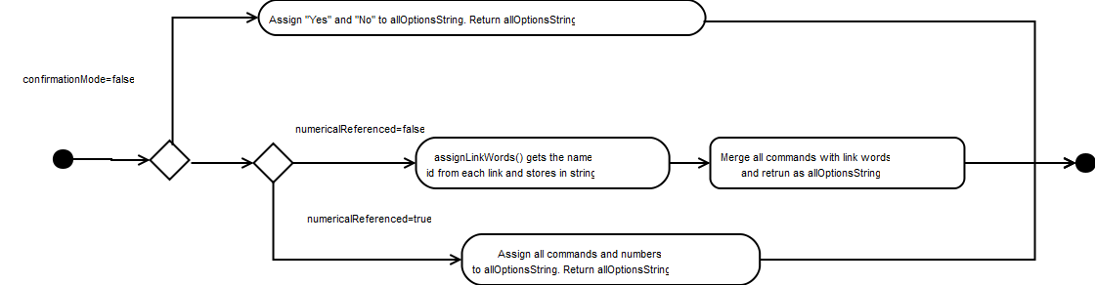

Figure : Determine total vocab overview

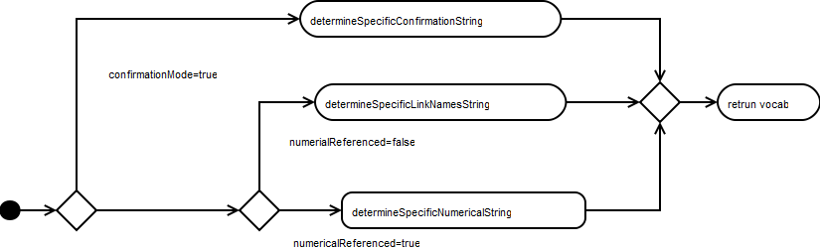

Figure :Determine specific vocab

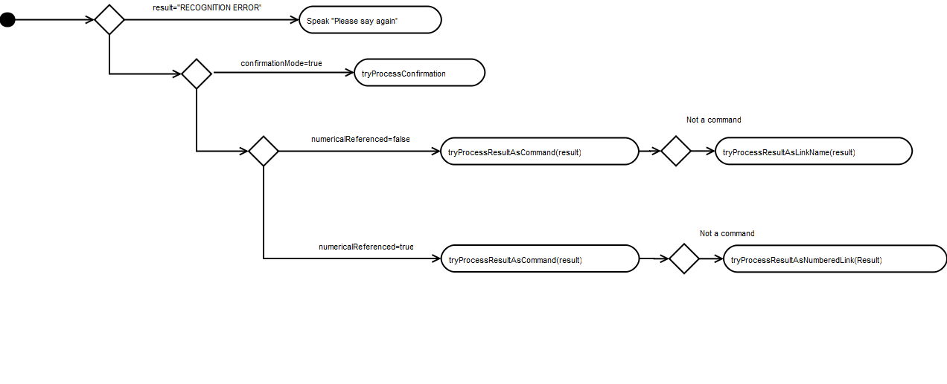

Figure : Result processing